**Classifying training drills based on movement demands in Australian Football**

Jordan Loader1

Paul Montgomery3

Morgan D. Williams1,2

Christian Lorenzen1,2

Justin G. Kemp1,2

1School of Exercise Science, Australian Catholic University, Locked Bag 4115, Fitzroy, Australia.

2 Centre of Physical Activity Across the Lifespan, Australian Catholic University, Locked Bag 4115, Fitzroy, Australia.

3 St Kilda Football Club, Linton St Moorabbin, Victoria 3188

**Corresponding Author:**

Morgan Williams

School of Exercise Science

Australian Catholic University

Locked Bag 4115, Fitzroy MDC

Fitzroy VIC, Australia 3065

Ph: (61-3-) 9953 3420

Fax: (61-3-) 9953 3095

Email: morgan.williams@acu.edu.au

**ABSTRACT**

Time-motion data was used to classify a selection of training drills. Ten midfielders (age=23.8±1.8yr; height=183.9±3.8cm; mass=83.2±5.0 kg) from an Australian Football League team participated in 17 training drills and four quarters of an official competitive match. Heart rate and time-motion data were collected using Global Positioning and Heart Rate Systems. Cluster analysis of mean distance travelled in the seven velocity zones identified three clusters: 1) game-specific conditioning; 2) skill refining/moderate intensity dominant; and 3) skill refining/low intensity dominant. Differences between the three clusters in distance travelled at the speed zones were confirmed using one-way ANOVA. Differences between clusters were also assessed for number of efforts in velocity zones and percentage time in heart rate zones. When compared to drills with a focus on skill refining or performed on a reduced playing area, drills utilising the entire playing field better replicated the movement characteristics of competitive game play.

**Introduction**

In team sport, a range of methods and technology are currently used to track and monitor athletes during both competitive games and training. Subsequently, rich data sets are generated for a variety of analytical purposes. Global Positioning Systems (GPS) simultaneously captured with Heart Rate (HR) monitoring are now routinely monitored in team sport, to assess the physiological and movement demands of athletes [1,2]. The widespread investment by sports teams and institutes in GPS and HR technology emphasises the value and importance held by the coaching staff for the information obtained from athlete monitoring. Australian Football is only one example where this daily athlete monitoring has been embraced.

Australian Football, like most other team sports is characterized by high intensity intermittent efforts interspersed with low to moderate physical activity. In Australian Football, competitive games are played on a large oval ground, they involve 22 players aside, with 18 on field at any one time, and each game is broken down into four quarters lasting approximately 30 minutes. Each quarter is separated by a 5 min break, with a half-time break of 20 minutes. Playing time and movement characteristics may vary depending on playing position or team role, and have been described based on GPS data previously [3-5]. Generally, players in midfield-nomadic type positions will have less game time and higher work rates compared to other positions [3-5]. To understand and facilitate program design, Sport Scientists and Coaches in Australian Football use GPS and HR devices to monitor the training and game loads of their players. Workloads are monitored internally and externally, where internal workload represents the physiological stress experienced by the individual and external workload quantifies the work performed (e.g. distance ran) [6-8]. Traditionally, percent time spent at given HR intensity bands has been the most widely accepted method for quantifying internal workload [6]. External load is typically monitored with GPS. Distance covered at defined velocity bands is reported in Australian Football, and other team sports, and has been used by the Australian Football League (AFL) to assess running performance over several competitive seasons [3-5].

GPS technology has been validated for measuring movement characteristics in team sports [9]. Using a simulated team sport circuit (Distance = 140m) an acceptable level of validity and reliability was reported. Compared to a ‘known’ distance, accuracy (standard error of estimate) was reported to be within 3.8 ± 0.6% [9]. Furthermore that study showed GPS derived data to improve reliability when devices sampled at 5Hz compared to 1Hz were used and when longer distances were assessed [9]. It is also considered more reliable compared to traditional manually-coded time-motion analysis [10], although recent reports have described limitations in the reliability and validity of GPS [9]. It should be noted, to date, a ‘gold standard’ for time motion measures obtained during competitive games and training does not exist [11]. The lack of a ‘gold standard’ measure to monitor time motion characteristics of athletes is explained by the complexity of movement patterns performed during team sport activity in addition to the physical size of the grounds used.

In Australian Football, despite the lack of a gold standard of time motion analysis, GPS is accepted as a measurement tool used extensively. A significant challenge faced by those Sport Scientists and Coaches who work in Australian Football, is the classification of training drills relative to the loads imposed. Classification of training loads for game-specific training drills can be particularly challenging and complex. Game-specific training drills, that are generally small-sided games, are common practice in soccer, rugby codes, as well as Australian Football. This type of training is considered beneficial for simultaneous skill acquisition and physiological adaptation since they are expected to replicate game demands [12-19]. Classification of drills from measures obtained from monitoring internal and external load during training sessions and competitive games is expected to provide a stronger understanding of the specificity of training drill design. Although previous studies have investigated the internal and external loads of training drills in other team sports, multiple univariate comparisons at each level (velocity band) were used to compare drills [e.g. 13,14]. Such data sets are inherently complex and are better suited to alternate forms of analysis used for data mining.

The purpose of this study was to measure the internal and external loads of a broad range of both training drills, and competitive match quarters performed by elite Australian footballers through the use of HR and GPS measurements. Moreover, cluster analysis, a classification tool, was applied to a time-motion data set for the specific purpose to group training drills based on the distance covered over the entire range of velocity bands (1 – 7). This form of analysis offers a parsimonious grouping yet encapsulates and retains the complexity and structure of the data set. Once classified, comparisons of the GPS and HR data between clusters were used to confirm the validity of groupings.

**Methods**

**Design**

Heart rate and GPS measures were collected from group of elite Australian footballers while taking part in game specific training drills (n=6) and skill refining drills (n=11) during team training sessions (n=33), and during competitive matches (n=10). Drill classification was based on the structure of the distance covered at given velocity zones. The classification was verified by comparisons of the drill clusters on physiological demands and work rates.

**Subjects**

The Institutional Review Board for Human Investigation approved all experimental procedures. Ten male professional midfield players (mean ± SD; age = 23.8 ± 1.8 y; height = 183.9 ± 3.8 cm; mass = 83.2 ± 5.0 kg) from the AFL participated in this study. All subjects were briefed regarding the purpose of the study and the protocols used for data collection. In addition, all subjects were injury free having completed 10 weeks of pre-season training and were training and playing competitive games weekly. All subjects signed a consent form declaring their understanding of the study requirements.

**Procedures**

Time-motion analysis was performed via GPS using Catapult MinimaxX units (Version 2.5, Catapult Innovations, Melbourne, Australia) with a mass of 67 g and operating at 5 Hz. Heart rate monitoring was performed using the in-built sensor of the Catapult MinimaxX, combined with Polar HR chest transmitters (Polar, Kempele, Finland)

The GPS devices were turned on 15 to 30 min prior to the commencement of data collection and placed one metre inside the boundary line of the training/playing arena, with approximately one metre between each GPS unit, until a signal was locked with the satellites. Immediately prior to the training session warm-up, and 15 min before the commencement of a game, the GPS units were placed inside the manufacturer’s harnesses worn by participants, locating the unit in the upper thoracic region, between the scapulae and data collection initiated. Units were always fitted in the same orientation. Team training commenced at the same time of day (14:00h). Training frequency was dependent upon the weekly game cycle and ranged from two to three sessions per week. All players presented to training and competitive games in self hydrated and carbohydrate loaded state. At the end of a training session or competitive game, the GPS and HR data were collected and data analysed using manufacturer’s software (LoganPlus, v4.3.1, Catapult Innovations, Melbourne, Australia). A total of 17 drills were analysed across the course of the study. All training data were collected within a 32 week period during routine sessions scheduled in the late pre-season and early in-season. All game data was collected in the five pre-season cup games and the first five AFL season games.

Examples of the two drills are presented in Figure 1. A brief description of all drills is listed in Table 1 (Further examples of Australian Football drills can be found at: <http://www.afl.com.au/skills%20and%20drills/tabid/10217/default.aspx>). Drills 1 – 6 were designed to replicate competitive game play in terms of movement characteristics, intensity demands and decision making characteristics. These drills involved two teams of varying sizes (e.g. 16 vs 16; 16 vs 9; 8 vs 8) competing for possession of the ball on fields of varying dimensions (e.g. full ground; half ground), aiming to apply skills and tactics to efficiently move the ball into a scoring opportunity. The presence of opposition pressure and the unpredictability of the ball movement required players to use their decision making abilities as they would in competitive game play.

Drills 7 – 17 were designed to practice essential football skills (e.g. kicking; handballing; marking) whilst at the same time improving a player’s fitness capabilities. The movement of the ball and actions performed in the drill were often pre-determined and, on most occasions, no opposition pressure was presented to the ball carrier. Each drill from every training session was analysed individually.

Figure 1. Training drill examples. A) An example of a game-specific drill on a full size ground using small-sided teams (14 vs 14). B) An example of a skill refining drill where movement patterns and performance tasks are prescribed.

The four quarters of competitive game play (Q1 – Q4) involved data collection during pre-season and in-season AFL competition. Data used were only those collected while a player was on the ground during a competitive AFL game, with periods of time on the interchange bench excluded.

**Table 1: Drill classification and descriptions used within this study.**

|  |  |  |  |
| --- | --- | --- | --- |
| **DRILL ID** | **DRILL CLASSIFICATION** | **DESCRIPTION** | **Total assessment time (min)** |
| 1 | Game-specific | Full ground | 127 |
| 2 | Game-specific | Full ground | 130 |
| 3 | Game-specific | Full ground, reduced players | 28 |
| 4 | Game-specific | Reduced ground, reduced players | 73 |
| 5 | Game-specific | Full ground | 244 |
| 6 | Game-specific | Full ground, few players | 17 |
| 7 | Skill refining | Full ground kicking/handball | 5 |
| 8 | Skill refining | Full ground kicking | 15 |
| 9 | Skill refining | Full ground kicking | 38 |
| 10 | Skill refining | Handballing, opposing players | 59 |
| 11 | Skill refining | Handballing and kicking | 71 |
| 12 | Skill refining | Kicking | 13 |
| 13 | Skill refining | Gather loose ball, bumping | 40 |
| 14 | Skill refining | Long kicking | 49 |
| 15 | Skill refining | Short kick, keepings off | 26 |
| 16 | Skill refining | Gather loose ball, evading | 35 |
| 17 | Skill refining | Handballing | 27 |
| Q1 | Competitive game play | - |  |
| Q2 | Competitive game play | - |  |
| Q3 | Competitive game play | - |  |
| Q4 | Competitive game play | - |  |

Velocity data were analysed for (i) distance (m) and (ii) number of efforts performed in each velocity band (m∙sec-1). GPS data were stratified into seven velocity bands defined as:

* Band one (standing/walking) = 0 – 1.7
* Band two (jogging) = 1.8 – 3.3
* Band three (moderate running) = 3.4 – 4.4
* Band four (fast running) = 4.5 – 5.6
* Band five (sprint) = 5.7 – 6.9
* Band six (maximal) = 7.0 – 8.3
* Band seven (maximal) > 8.3

Similarly, heart rate data were analysed for the percentage time spent in each heart rate band. Heart rate (beats∙min-1)data were stratified into eight bands defined [6] as:

* band 1 = 0 – 80
* band 2 = 81 – 100
* band 3 = 101 – 120
* band 4 = 121 – 140
* band 5 = 141 – 160
* band 6 = 161 – 180
* band 7 = 181 – 200
* band 8 = 201 – 220

**Statistical Analyses**

Because training drills and on-field playing time in competition varied in duration, GPS results were standardised to m∙min-1, efforts∙min-1; and HR standardised to percentage time in each HR band to allow for comparison between bands. To categorise the training drills and competitive game play, a Ward’s two-way hierarchical cluster analysis was performed using the mean distance (m∙min-1) covered in each velocity band. The group mean was used for the analysis as a representative value for the group of players. The number of clusters was determined by the accompanying scree plot. Following clustering of the distances, a one-way ANOVA with Tukey-Kramer’s Honestly Significant Difference (HSD) test at each velocity band was used to confirm differences between the clusters, thus providing a level of concurrent validity to the analysis. Using one-way ANOVA with Tukey’s HSD, differences in efforts and HR variables were then also explored. Statistical significance was set at P < 0.05. All data analyses were performed using JMP version 8.0(SAS Institute Inc).

**Results**

The Ward’s two-way hierarchical cluster analysis grouped drills and competitive game play into one of three clusters illustrated by a dendrogram (Figure 2). Referring to the y-axis in Figure 1, the dendrogram shows that cluster 1 contained four training drills with full-ground characteristics (1, 2, 3 and 5), and all competitive game play (Q1, Q2, Q3 and Q4), indicating that similar distances (m∙min-1) were covered within these drills/competitive game play for each velocity band. Cluster 1 was therefore termed ‘game-specific conditioning’. Cluster 2, defined as ‘skill refining/moderate intensity dominant’ (drills 4, 6, 7, 8, 9, 10, 11, 12, 14 and 16), all shared similar distances (m∙min-1) covered within each velocity band. Although some of these drills may have used the full ground, they did not have the characteristics of game specific full ground drills. Finally, cluster 3 included drills 13, 15 and 17, which were the least intensive skill refining drills and were defined as ‘skill refining/low intensity dominant’.

**Figure 2. Ward’s two-way hierarchical cluster analysis illustrated by dendrogram for distance (m/min).**



NB., On the x-axis, bands one to seven represent velocity ranges from 0 – 6 km/hr to greater than 30 km/hr. On the y-axis, numbers 1 – 17 represent training drills and Q1 – Q4 represents competitive game data. The intensity of greyscale of the squares represents the amount of distance (m∙min-1) performed in each velocity band. Dark indicates high amounts of distance performed in a velocity band while light signifies the least amount of distance performed.

The subsequent one-way ANOVA (with Tukey’s-Kramer HSD), where comparisons of distance, efforts and HR data of the clusters were performed, found significant differences between clusters. Of particular note (Figure 3), significantly greater distances (m∙min-1) were performed in standing/walking and maximal velocity bands (band six and seven) for ‘game-specific conditioning’ when compared to ‘skill refining/moderate intensity dominant’ and cluster ‘skill refining/low intensity dominant’. Furthermore, ‘skill refining/low intensity dominant’ had less distance (m∙min-1) travelled compared to ‘game-specific conditioning’ for jogging, moderate running, fast running and sprinting. Also, ‘skill refining/low intensity dominant’ had less distance travelled when compared to ‘skill refining/moderate intensity dominant’ for jogging, moderate running, fast running, sprinting, and maximal running. No significant differences existed for other comparisons with regards to distance (m∙min-1) performed in velocity bands.

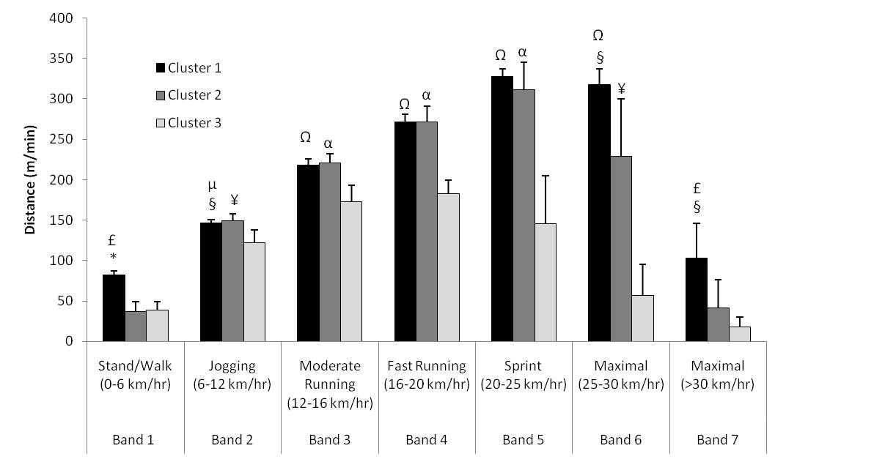

**Figure 3: Distance (m∙min-1) travelled in band zones for clusters 1, 2 and 3. Note: Distance has been standardised to m/min due to variations in training drill durations and playing time. * Significantly different from cluster 2 at *p < 0.0001 and §p < 0.01. £Significantly different from cluster 3 (p < 0.01). Cluster 1 significantly different from cluster 3 at µ p < 0.001 and at Ω p < 0.0001. Cluster 2 significantly different from cluster 3 at ¥ p < 0.0005 and α p < 0.0001.**

With respect to efforts∙min-1 (Figure 4), at bands 4, 5 and 6, clusters ‘game-specific conditioning’ and ‘skill refining/low intensity dominant’ had higher number of efforts than cluster ‘skill refining/moderate intensity dominant’. At band 6 only, efforts∙min-1 were greater in cluster ‘game-specific conditioning’ compared to cluster ‘skill refining/low intensity dominant’. At band 3 more efforts were observed in cluster ‘skill refining/low intensity dominant’ than cluster ‘game-specific conditioning’ only. No significant differences existed for other comparisons with regards to efforts∙min-1 performed in velocity bands.

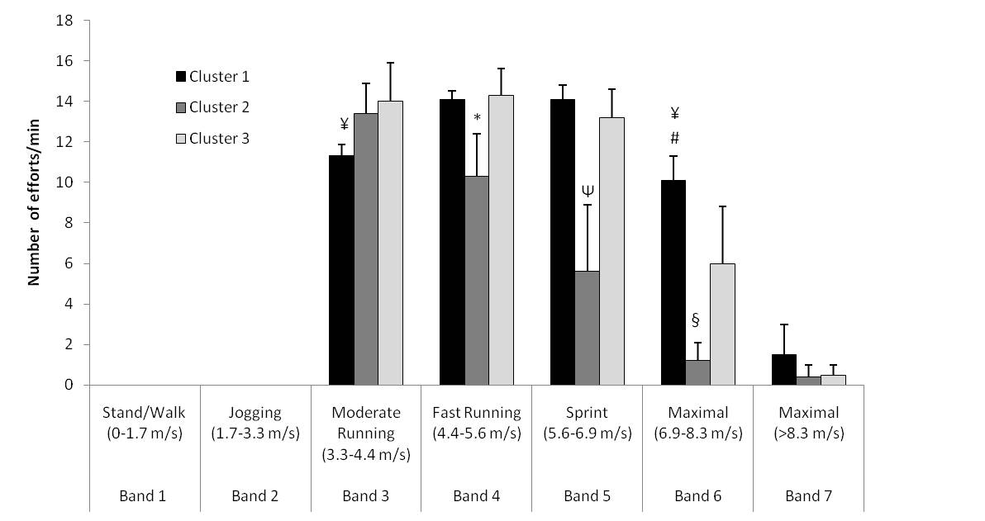

**Figure 4: Distance (efforts/min) travelled in band zones for clusters 1, 2 and 3. Note: Distance has been standardised to efforts/min due to variations in training drill durations and playing time. Significantly different to cluster 1 and 3 at *p < 0.001 and Ψp < 0.0001. #Significantly different to cluster 2 (p < 0.0001). Significantly different to cluster 3 at §p < 0.01 and ¥p < 0.01.**

For HR data, differences between clusters were found only at band 7. At band 7, cluster ‘game-specific conditioning’ (14.4 ± 8.2%) had a greater percentage of time performed at 181-200 beats∙min-1- compared to cluster ‘skill refining/low intensity dominant’ (4.0 ± 3.9%, p<0.01). No additional significant differences existed for other comparisons with regards to percentage time performed in HR bands.

**Discussion**

The aim of the current investigation was to classify training drills typically performed in Australian Football based on time-motion demands obtained from GPS devices during training and competitive game play. To achieve this we used cluster analysis, a classification tool. Even in the absence of a gold standard measure for time-motion analysis the study confirmed, within the limits of our experimental methods, the movement demands and intensity levels of drills classified as game specific conditioning simulate those of competitive game play, while skill refining drills of both moderate and low physiological intensity did not replicate these characteristics. These findings are novel, given all previous reports used multiple univariate comparisons searching for differences rather than statistical analysis for the specific purpose of classification. The findings also provide empirical evidence where in the past Sport Scientists and Coaches have relied on more subjective ‘face value’ evaluations or heart rate only to classify training drills, whereas this approach combines both physical and physiological responses.

In this study, our classification tool identified four of the six drills designed to replicate competitive game play were found to resemble distances covered at each velocity band, number of efforts performed per min and HR responses for any quarter of a competitive match. Further analysis showed that these four drills and competitive game play also recorded greater distances and number of efforts performed at maximal velocities than all other training drills. This finding was supported by the HR data which showed significantly larger proportions of time spent at heart rates of higher intensity (181-200 beats∙min-1) in these drills and in competition. The similar characteristics can be explained by the requirement of players to apply offensive and defensive pressure in game specific conditioning drills which involves running at high velocities to either chase opponents, gain possession of a loose ball, or to be in the best position to receive the ball. More specifically, these drills were performed on full sized fields with little to no modification of player numbers suggesting that such characteristics best replicate the movement demands of competitive game play. This finding is consistent with previous research on team sports concluding that game-specific drills (competition sized fields and player numbers) best simulate the movement demands of competition, and manipulating the structure (field size and player numbers) of drills reduces the high intensity, repeated sprint demands of competitive game play [14, 17]. Physiologically, these results support previous research demonstrating that skill-based conditioning games are acceptable substitutes for interval based training to maintain specific fitness during the competitive season [18, 19].

The cluster analysis also showed that two drills, despite their design to ‘mimic’ game play, were not similar to the movement demands of competitive games. This was reflected in HR values predominantly in the moderate intensity (121-160 beats∙min -1) range. Specifically, one drill was performed in a small sized area with vastly reduced player numbers, whilst the other was performed on a full size ground but involved few players. A reduced playing area may restrict, or not require, the player to perform movements seen in competitive game play due to the lack of free space. This may, in turn, result in players reducing their training load, as they only need to perform moderate efforts in order to gain possession of the ball, make position to receive the ball, or apply defensive pressure to the opposition. Alternatively, limiting the player numbers in a drill may reduce the defensive pressure applied to the ball carrier and increase the area of free space in which to perform, thus allowing players to perform at lower intensities to successfully complete the specific training drill tasks. Taken together, these data indicate that altering the structure of game-specific drills by reducing field size or player numbers will reduce the competitive game-specificity of time-motion and work intensity parameters of such drills. This is in contrast to other studies that have reported that small-sided games in soccer are suitable for conditioning athletes while developing skills and tactics [13-14]. However, these studies did not compare training (physiological and GPS) data with data collected from competitive game play.

Skill refining/moderate intensity dominant and skill refining/low intensity dominant drills were not found to be similar to the GPS or intensity demands of competitive game play. In fact, the present study indicates that these types of drills are predominantly of lesser workload compared to game-specific drills and competitive game play. Therefore, skill refining drills may not be appropriate for stimulating game-specific physiological adaptations or replicating the movement pattern of competitive game play. Due to their lower intensity nature, coaching staff may choose to use these drills during periodisation cycles of lower volume and/or intensity or during earlier stages of learning game play tactics.

The distances covered in the velocity zones of standing/walking and maximal were significantly greater in game specific conditioning than in skill refining/moderate intensity dominant and skill refining/low intensity dominant drills. Thus, in these velocity zones, showing that greater distances are covered in competitive game play and game-specific drills that utilise a full playing area compared to drills with modified player numbers, playing area and/or rules. These data also suggest that training drills can provide players with appropriate periods of rest after maximal efforts, in order to recover, similar to those experienced in competition.

**Conclusion**

Cluster analysis was shown to effectively classify training drills and competitive games based on the similarity of distance covered over the entire range of velocity bands. From our data set, the HR responses and GPS derived demands of competitive Australian Football were best replicated by game-specific drills that made use of the entire playing field. In contrast, drills that restrict playing area, player numbers and/or have a greater focus on skill development reduce the specificity of training to meet competitive demands, but have benefit for reducing player workload while maintaining skill and fitness requirements.

**Practical APplications**

The data collection used in this study is commonly used in the team sports domain. Moreover, classification of drills based on the measures obtained from GPS and HR monitoring is an interest to Sport Scientists and Coaches of team sports. This study shows that cluster analysis can be a useful approach. It is an appropriate classification tool that groups the drills or game quarters based on the complexity and structure of the profile of loads across all velocity bands, avoiding multiple univariate comparisons. Coaches, practitioners and sports scientist working within Australian Football should be aware of the physical and physiological demands associated with differing training drills during the preparation of training sessions, and the weekly training program.

In the context of elite Australian Football:

* coaches can choose training drills (game-specific or skill refining) to design a training session that is high, moderate or low in movement demands/intensity levels depending on the desired training outcomes.
* game-specific training drills performed on a full playing area with little to no modification of player numbers appears to have similar movement demands and intensity levels as competitive game play, suggesting they are more appropriate in stimulating physiological responses and time-motion demands relevant to competitive game play.
* skill refining drills are of moderate to low movement demand and intensity. Coaches should consider the relevance of these drills for skill execution in the intensity of competition.

**Acknowledgements**

There was no outside support this research (including financial and equipment for support).

**References**

1. Castagna, C., Manzi, V., Impellizzeri, F., Weston, M., Barbero, and Alvarez, JC., Relationship Between Endurance Field Tests and Match Performance in Young Soccer Players. Journal of Strength & Conditioning Research, 2010, 24 (12), 3227-3233.
2. Cunniffe, B., Proctor, W., Baker, J.S., Davies, B., An Evaluation of the Physiological Demands of Elite Rugby Union Using Global Positioning System Tracking Software. Journal of Strength & Conditioning Research, 2009, 23 (4), 1195-203.
3. Wisbey, B. and Montgomery, P.G., Quantifying Changes in AFL Player Game Demands Using GPS Tracking: 2007 AFL Season. Australian Capital Territory, Fitsense Australia, 2007.
4. Wisbey, B., Pyne, D.B., and Rattray, B., Quantifying Changes in AFL Player Game Demands Using GPS Tracking: 2008 AFL Season. Australian Capital Territory, Fitsense Australia, 2008.
5. Wisbey, B., Montgomery, P.G., Pyne, D.B., and Rattray, B., Quantifying Movement Demands of AFL Football Using GPS Tracking. Journal of Science and Medicine in Sport, 2009, 13 (5), 531-536.
6. Foster, C., Florhaug, J.A., Franklin, J., et al., A New Approach to Monitoring Exercise Training. Journal of Strength and Conditioning Research, 2001, 15 (1), 109-115.
7. McGuigan, M.R. and Foster, C., A New Approach to Monitoring Resistance Training. Strength and Conditioning Journal, 2004, 26 (6), 42-47.
8. Wallace, L., Coutts, A., Bell, J., et al., Using Session-RPE to Monitor Training Load in Swimmers. Strength and Conditioning Journal, 2008, 30 (6), 72-76.
9. Jennings, D., Cormack, S., Coutts, A.J., et al.,The Validity and Reliability of GPS Units for Measuring Distance in Team Sport Specific Running Patterns.International Journal of Sports Physiology and Performance, 2010, 5 (3), 328-341.
10. Edgecombe, S. and Norton, K., Comparison of Global Positioning and Computer-Based Tracking Systems for Measuring Player Movement Distance During Australian Football. Journal of Science and Medicine in Sport, 2006, 9 (1-2), 25-32.
11. Randers, M.B., Mujika, I., Hewitt, A., et al., Application of Four Different Football Match Analysis Systems: A Comparative Study.Journal of Sport Sciences, 2010, 28 (2), 171-182.
12. Gamble, P., A Skill-Based Conditioning Games Approach to Metabolic Conditioning for Elite Rugby Football Players.Journal of Strength and Conditioning Research, 2004, 18 (3), 491-497.
13. Hill-Haas, S., Coutts, A., Rowsell, G., et al., Variability of Acute Physiological Responses and Performance Profiles of Youth Soccer Players in Small-Sided Games. Journal of Science and Medicine in Sport, 2008, 11(5), 487-490.
14. Kelly, D.M., and Drust, B., The Effect of Pitch Dimensions on Heart Rate Responses and Technical Demands of Small-Sided Soccer Games in Elite Players. Journal of Science and Medicine in Sport, 2009, 12 (4), 475-479.
15. Gabbett, T.J., GPS Analysis of Elite Women’s Field Hockey Training and Competition. Journal of Strength and Conditioning Research, 2010, 24 (5), 1321-1324.
16. Hill-Haas, S, Rowsell, G.J., Dawson, B.T., et al., Acute Physiological Responses and Time-Motion Characteristics of Two Small-Sided Training Regimes in Youth Soccer Players. Journal of Strength and Conditioning Research, 2009, 23 (1), 111-115.
17. Gabbett, T.J., and Mulvey, M.J., Time-Motion Analysis of Small-Sided Training Games and Competition in Elite Women Soccer Players. Journal of Strength and Conditioning Research, 2008,22 (2), 534-552.
18. Farrow, D., Pyne, D., and Gabbett, T., Skill and Physiological Demands of Open and Closed Training Drills in Australian Football. International Journal of Sports Science & Coaching, 2008, 3 (4), 489-499.
19. Gabbett, T.J., Skill-Based Conditioning Games as an Alternative to Traditional Conditioning for Rugby League Players, Journal of Strength and Conditioning Research*,* 2006, 20 (2), 309-315.